**Biography: Junbo Ge, MD, FACC, FAHA, FESC, FSCAI**

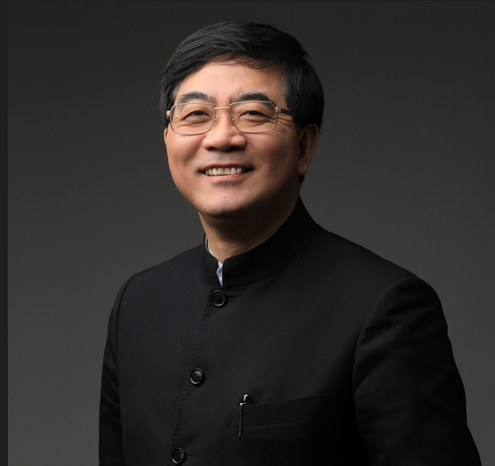

Junbo Ge, born in 1962, received his doctorate degree in University Mainz, Germany in 1993. In 1995, he was promoted as the director of the Intravascular Ultrasound lab of the Department of Cardiology, University Essen, Germany. In 1999, he was invited to Shanghai, China and working as co-director of the Department of Cardiology of Zhongshan Hospital, Fudan University.

Prof. Ge is now Academician of Chinese Academy of Sciences; Director of the Department of Cardiology, Zhongshan Hospital, Fudan University; Chairman of Shanghai Cardiovascular Clinical Center and Chairman of Shanghai Institute of Cardiovascular Diseases; Dean of Institutes of Biomedical Sciences, Fudan University; Chairman of National Clinical Research Center for Interventional Medicine.

He is also the President of Chinese College of Cardiovascular Physicians, President of Chinese Cardiovascular Association, Past President of Chinese Society of Cardiology (2015-2018); International Governor of American College of Cardiology, Board Member of World Heart Federation, Daniel L. Macken Visiting Professor of Columbia University.

Dr. Ge is devoted to academics, not only has made great achievements in clinical and scientific research, but also has rich experience in composing textbooks and operating journals. He has been responsible for over 120 international and national scientific research projects. He has published more than 639 papers as first author or corresponding author in international peer reviewed journals. He has edited and co-edited 25 monographs and textbooks.

He is also the Deputy editor of *International Journal of Cardiology*, Deputy Editor of *Herz*, Deputy Editor of *Heart*，Editor-in-Chief of *Cardiology Plus*, Chief Editor of Textbook of Internal Medicine (8th and 9th editions), Chief Editor of Practical Internal Medicine (15th and 16th edition) and international editorial board of many international academic journals.

He has long been engaged in cardiovascular disease research and interventional cardiology. In 2005, he created the retrograde wire technique and transmitted live demonstration to TCT for the first time which has been becoming the routine approach for coronary chronic total occlusion. He then modified the technique with the named AGT (active greeting technique) which made the intervention procedure easier and time saving. These techniques greatly improved the success rate of coronary chronic total occlusion. He leds his group developed and patented many innovative devices including biodegradable polymer DES, As2O3 drug coated stent, transapical mitral valve repair device ValveClamp. In 1999, he implemented the "green channel" treatment concept of acute myocardial infarction which has been developed to the China's chest pain treatment system, China Chest Pain Center, which covers about more than 4000 hospitals throughout China and rescued millions of emergent patients.

He has done hundreds of live transmissions of coronary intervention to most of the international meetings such as TCT, Euro-PCR, CCT, and national meetings. He has been invited to more than 20 countries including Indonesia, Kazakhstan, Kyrgyzstan, Bangladesh, India, Japan, Korean, Singapore, South Africa, India, and the Philippines etc. to do live demonstrations of coronary intervention. Under his leadership, CCA has established close relationship with most of the international cardiovascular societies and 52 well-known medical centers.