
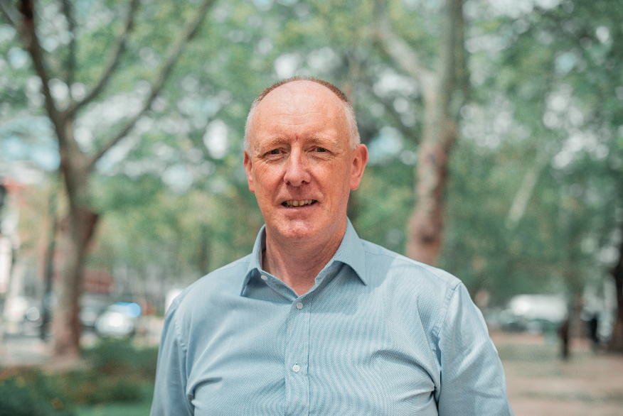
Neil Johnson
Executive Director, Global Heart Hub (GHH)

Neil Johnson is a founder and the current Executive Director of the Global Heart Hub (www.globalhearthub.org), the first international alliance of heart patient organisations. The Global Heart Hub aims to provide a voice for those living with or affected by cardiovascular disease.

Neil was Chief Executive of the Irish Heart & Stroke non-profit organisation, Croí (www.croi.ie) from 1992–2023 and he initiated and led the establishment of the Irish National Institute for Prevention and Cardiovascular Health – an independent medical research and education institute - (www.nipc.ie) from 2014–2023. NIPC has since spearheaded the development & delivery of a suite of MSc postgraduate courses in CVD Prevention at the University of Galway (Ireland) and is leading a significant program of international epidemiological research projects under the direction of Prof David Wood and Prof Bill McEvoy.

Neil has extensive senior management and development experience in the social enterprise sector, over 32 years of which are in the field of cardiovascular health – working across prevention, education, patient engagement, service innovation & implementation and patient advocacy. He is a founder of Ireland’s first Heart & Stroke Centre dedicated to cardiovascular health and wellbeing which has been accredited by the European Society of Cardiology as a European Centre of Excellence in CVD prevention.

He holds a first-class honours master’s degree in psychology. He is an Honorary Clinical Fellow of the School of Medicine at the University of Galway, Ireland, and a Fellow of the National Institute for Prevention and Cardiovascular Health. Among awards he has received, in November 2023, the University of Galway awarded him an Honorary Doctorate in Laws (LLD) in recognition of his work in the field of cardiovascular health promotion and patient advocacy. Among his other awards and recognitions are: Marketing Person of the Year Ireland (2007); Galway Person of the Year (2007); NIPC Fellow (2019); World Heart Foundation, Heart Hero (2022); and European Patient Forum, Inaugural ‘Hall of Fame’ award (2023).

Throughout his career he has worked closely with individuals and families affected by cardiovascular diseases. In 2019 he established the Global Heart Hub (GHH) as the first umbrella organisation of international heart patient organisations. Currently, GHH has 126 patient organisation affiliates from across 41 countries. In 2023, he was instrumental in establishing Heart & Stroke Voice Ireland, a national alliance of heart patients, stroke survivors and carer’s seeking to represent the unmet needs of this community. He is a strong proponent of patient engagement in all aspects of healthcare. He has a keen interest in patient organisation capacity and capability building and he is a regular patient advocate contributor to international healthcare, industry and research advisory boards.

